Experiment 15: Create a Snapshot of a VM and Test it by Loading the Previous Version / Cloned VM

Aim
To create a snapshot of a virtual machine using VMware Workstation, clone the virtual machine, and verify that the previous version can be restored successfully.

Requirements
• VMware Workstation (Type-2 Hypervisor)
• Ubuntu Virtual Machine
• Windows Host Operating System

Procedure
Step 1: Open VMware Workstation and select the configured Ubuntu virtual machine.
Step 2: Verify the VM configuration (2 GB RAM, 1 Processor).
Step 3: Verify the virtual hard disk (15 GB) allocation.
Step 4: Attach the Ubuntu ISO file through the CD/DVD settings.
Step 5: Create a clone of the virtual machine by providing a clone name and storage location.
Step 6: Complete the cloning process and verify the cloned virtual machine is available.

Figure 1: Memory Configuration (2 GB RAM)
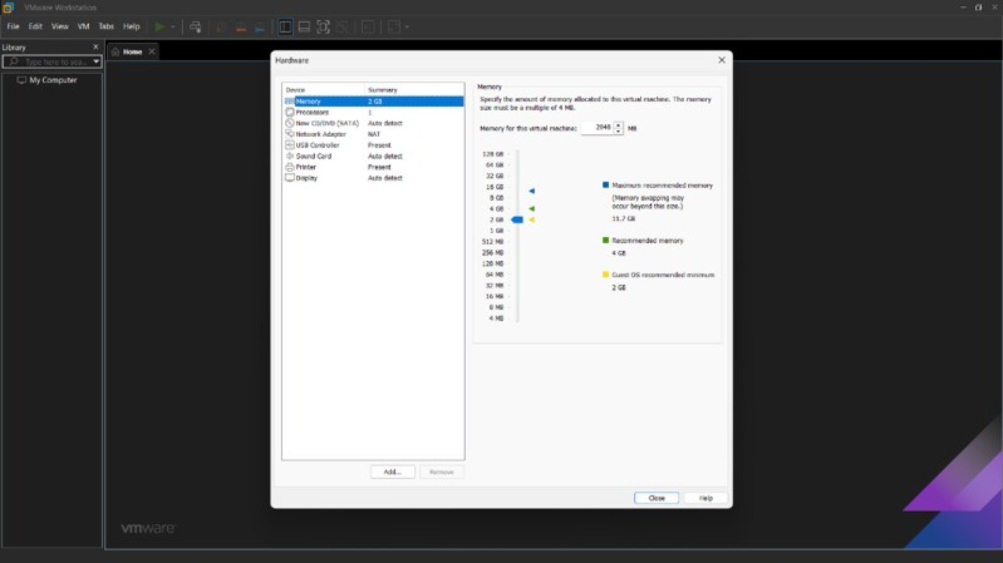

Figure 2: Processor Configuration (1 CPU)
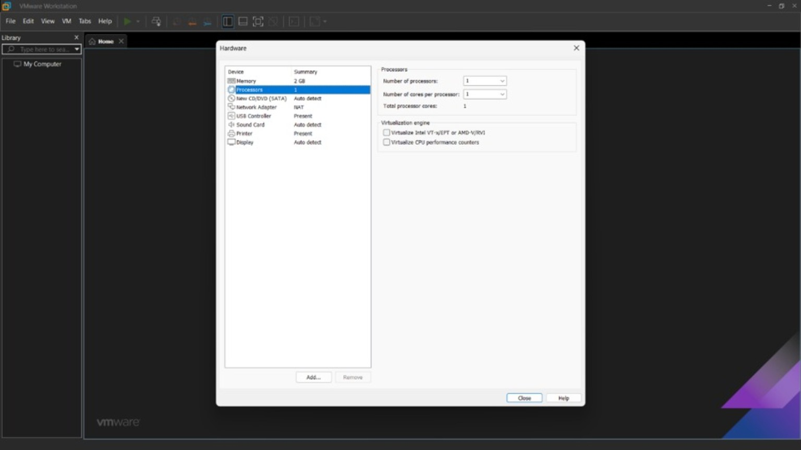

Figure 3: Virtual Hard Disk (15 GB)
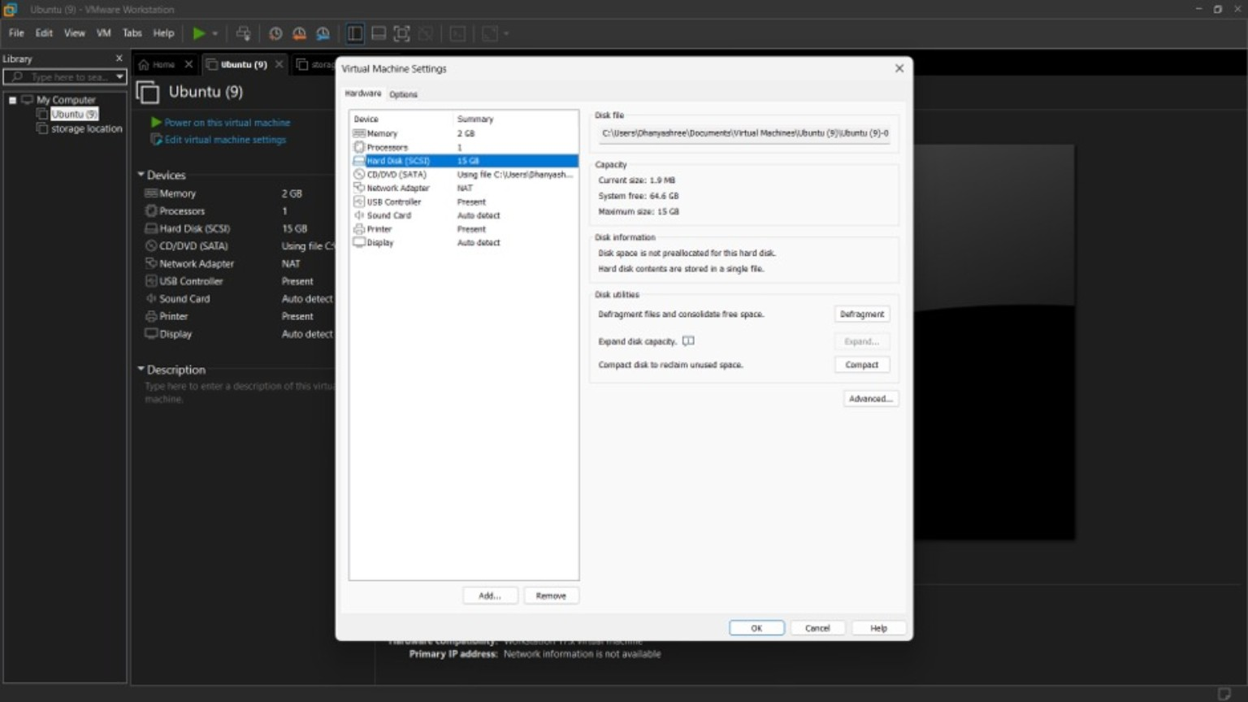

Figure 4: ISO Image Attached
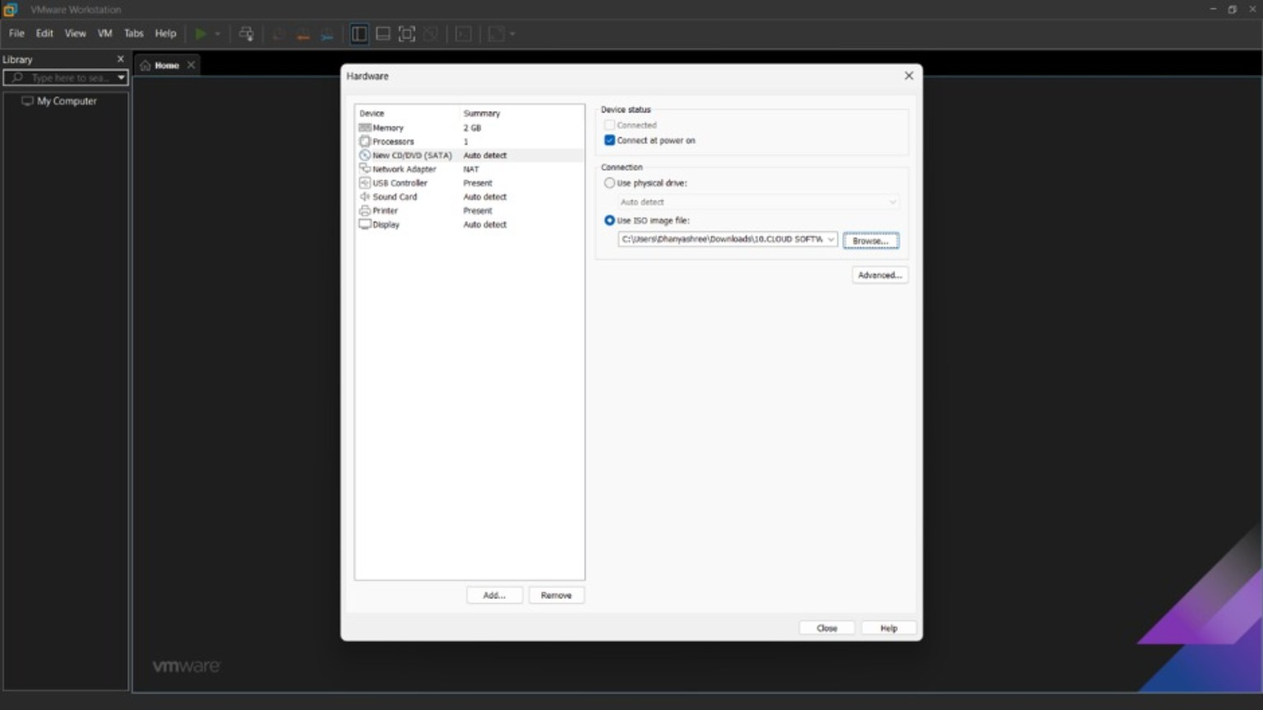

Figure 5: Clone Virtual Machine Wizard
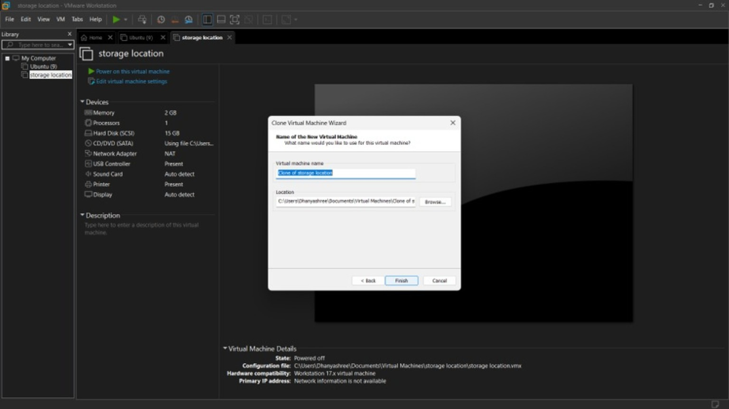

Figure 6: Cloned Virtual Machine Created
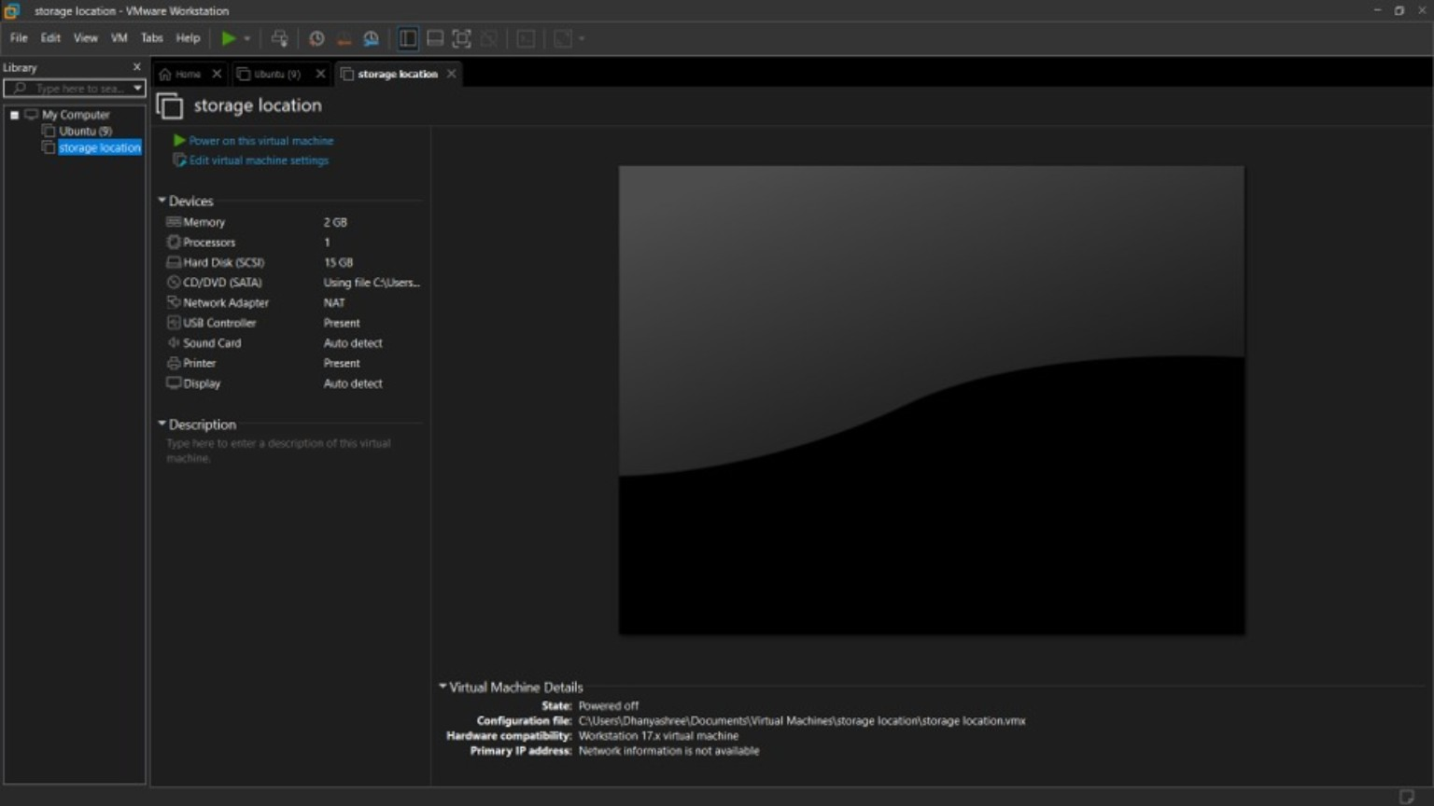

Observation
The snapshot/clone operation was completed successfully. The VM configuration remained unchanged with 2 GB RAM, 1 CPU, and 15 GB virtual hard disk. The cloned virtual machine was created successfully and can be used to restore the previous state whenever required.

Result
Thus, a snapshot/cloned virtual machine was successfully created using VMware Workstation, and the previous version can be loaded for recovery and testing purposes.

